Contents
TS C001 V3.0.0 (1999-10)
Technical Specification
China Wireless Telecommunication Standard (CWTS);
Working Group 1 (WG1);

Radio Interface Protocol Architecture


Foreword 4
1 Scope 5
2 References 5
3 Definitions and Abbreviations 6
3.1 Definitions 6
3.2 Abbreviations 6
4 Assumed TD-SCDMA Architecture 8
5 Radio interface protocol architecture 8
5.1 Overall protocol structure 8
5.2 Layer 1 Services and Functions 10
5.2.1 L1 Services 10
5.2.1.1 Transport channels 10
5.2.2 L1 Functions 11
5.3 Layer 2 Services and Functions 12
5.3.1 MAC Services and Functions 12
5.3.1.1 MAC Services to upper layers 12
5.3.1.1.1 Logical channels 12
5.3.1.1.1.1 Control Channels 13
5.3.1.1.1.2 Traffic Channels 14
5.3.1.1.2 Mapping between logical channels and transport channels 14
5.3.1.2 MAC functions 15
5.3.2 RLC Services and Functions 17
5.3.2.1 Services provided to the upper layer 17
5.3.2.2 RLC Functions 18
5.3.3 Data flows through Layer 2 19
5.3.3.1 Data flow for BCCH mapped to BCH (FFS.) 21
5.3.3.2 Data flow for PCCH mapped to PCH (FFS.) 22
5.3.3.3 Data flow for SCCH mapped to SCH (FFS.) 22
5.3.3.4 Data flow for CCCH mapped to FACH/RACH (FFS) 22
5.3.3.5 Data flow for DCCH mapped to FACH/RACH 22
5.3.3.6 Data flow for DCCH mapped to DSCH 22
5.3.3.7 Data flow for DTCH (non-transparent RLC) mapped to FACH/RACH 22
5.3.3.8 Data flow for DTCH (non-transparent RLC) mapped to DSCH 22
5.3.3.9 Data flow for DTCH (transparent RLC) mapped to DCH 22
5.3.3.10 Data flow for DTCH (non-transparent RLC) mapped to DCH 22
5.3.3.11 Data flow for DCCH mapped to DCH 22
5.4 Layer 3 - RRC Services and Functions 23
5.4.1 RRC services 23
5.4.1.1 General Control 23
5.4.1.2 Notification 23
5.4.1.3 Dedicated Control 23
5.4.2 RRC functions 24
5.5 Interactions between RRC and lower layers in the C plane 26
5.6 Protocol termination 26
5.6.1 Protocol termination for DCH 26
5.6.2 Protocol termination for RACH/FACH 27
5.6.3 Protocol termination for DSCH 29
5.6.3.1 DSCH definition 29
5.6.3.2 Resource allocation and UE identification on DSCH 29
5.6.3.2.1 Case A (UE requires a downlink TFCI on a DPCCH) 29
5.6.3.2.2 Case B (UE requires a FACH or DSCH) 29
5.6.3.3 Model of DSCH in RAN 30
5.6.3.4 Protocol termination 30
5.6.4 Protocol termination for transport channel of type BCH 31
5.6.5 Protocol termination for transport channel of type PCH 31
5.6.6 Protocol termination for transport channel of type SCH 32
5.6.7 Protocol termination for ODCH 32
5.6.8 Protocol termination for ORACH 33
6 User Identification and RRC Connection Mobility 34
6.1 UE identification within RAN 34
6.2 UE connection to RAN 35
7 UE modes 35
8 Ciphering ( FFS in CWTS) 36
Appendices 37
History 40

Foreword
This Technical Specification has been produced by the CWTS WG1 Ad Hoc1.
The contents of the present document are subject to continuing work within the CWTS and may change following formal WG1 approval. Should the WG1 modify the contents of this TS, it will be re-released by the CWTS with an identifying change of release date and an increase in version number as follows:
Version x.y.z
where:
x the first digit:
1 presented to CWTS for information;
2 presented to CWTS for approval;
3 Indicates CWTS approved document under change control.
y the second digit is incremented for all changes of substance, i.e. technical enhancements, corrections, updates, etc. Which should be approved by Ad Hoc 1.
z the third digit is incremented when editorial only changes have been incorporated in the specification;

Scope
The present document shall provide an overview and overall description of the UE-RAN radio interface protocol architecture which will be presented to CWTS WG1 for decision;. Details of the radio protocols will be specified in companion documents.

References
The following documents contain provisions which, through reference in this text, constitute provisions of the present document.
- References are either specific (identified by date of publication, edition number, version number, etc.) or non-specific.
- For a specific reference, subsequent revisions do not apply.
- For a non-specific reference, the latest version applies.
- A non-specific reference to a TS shall also be taken to refer to later versions published as an EN with the same number.

- 3GPP TS 23.110: “UMTS Access Stratum; Services and Functions”
- 3GPP TS 25.401: “RAN Overall Description”
- 3GPP TR 25.945: “Vocabulary for the UTRAN”
[4] 3GPP TS 25.302: “Services Provided by the Physical Layer”
[5] 3GPP TS 25.303: “UE Functions and Inter-Layer Procedures in Connected Mode”
[6] 3GPP TS 25.304: “UE Procedures in Idle Mode”
[7] 3GPP TS 25.321: “MAC Protocol Specification”
[8] 3GPP TS 25.322: “RLC Protocol Specification”
[9] 3GPP TS.25.331: “RRC Protocol Specification”
[10] CWTS TS C002: “Services Provided by the Physical Layer”
[11] CWTS TS C201: “MAC Protocol Specification”
[12] CWTS TS C202: “RLC Protocol Specification”
[13] CWTS TS C203: “RRC Protocol Specification”
[14] CWTS TS C003: “UE Functions and Inter-Layer Procedures in Connected Mode”
[15] CWTS TS C004: “UE Procedures in Idle Mode”

Definitions and Abbreviations

Definitions
See [3] for a definition of fundamental concepts and vocabulary.

Abbreviations

ARQ Automatic Repeat Request
BCCH Broadcast Control Channel
BCH Broadcast Channel
- Control-
CC Call Control
CCCH Common Control Channel
CCH Control Channel
CCTrCH Coded Composite Transport Channel
CN Core Network
CRC Cyclic Redundancy Check
CTCH Common Traffic Channel
DC Dedicated Control (SAP)
DCA Dynamic Channel Allocation
DCCH Dedicated Control Channel
DCH Dedicated Channel
DL Downlink
DRNC Drift Radio Network Controller
DSCH Downlink Shared Channel
DTCH Dedicated Traffic Channel
FACH Forward Link Access Channel
FAUSCH Fast Uplink Signalling Channel
FCS Frame Check Sequence
FDD Frequency Division Duplex
GC General Control (SAP)
HO Handover
ITU International Telecommunication Union
kbps kilo-bits per second
L1 Layer 1 (physical layer)
L2 Layer 2 (data link layer)
L3 Layer 3 (network layer)
LAC Link Access Control
LAI Location Area Identity
MAC Medium Access Control
MM Mobility Management
Nt Notification (SAP)
OCCCH ODMA Common Control Channel
ODCCH ODMA Dedicated Control Channel
ODCH ODMA Dedicated Channel
ODMA Opportunity Driven Multiple Access
ORACH ODMA Random Access Channel
ODTCH ODMA Dedicated Traffic Channel
PCCH Paging Control Channel
PCH Paging Channel
PDU Protocol Data Unit
PU Payload Unit
PHY Physical layer
PhyCH Physical Channels
RAB Radio Access Bearer
RACH Random Access Channel
RLC Radio Link Control
RNC Radio Network Controller
RNS Radio Network Subsystem
RNTI Radio Network Temporary Identity
RRC Radio Resource Control
SAP Service Access Point
SCCH Synchronization Control Channel
SCH Synchronization Channel
SDU Service Data Unit
SRNC Serving Radio Network Controller
SRNS Serving Radio Network Subsystem
TCH Traffic Channel
TDD Time Division Duplex
TFCI Transport Format Combination Indicator
TFI Transport Format Indicator
TMSI Temporary Mobile Subscriber Identity
TPC Transmit Power Control
U- User-
UE User Equipment
UE_{R} User Equipment with ODMA relay operation enabled
UL Uplink
UMTS Universal Mobile Telecommunications System
URA UTRAN Registration Area
USCH Uplink Shared Channel
UTRA UMTS Terrestrial Radio Access
UTRAN UMTS Terrestrial Radio Access Network

Assumed TD-SCDMA Architecture
Figure 1 shows that the TD-SCDMA will use the architecture show in figure 1.in terms of entities User Equipment (UE), RAN and Core Network. The respective reference points Uu (Radio Interface) and Iu (CN-RAN interface) are shown. The figure illustrates furthermore the high-level functional grouping into the Access Stratum and the Non-Access Stratum.
The Access Stratum offers services through the following Service Access Points (SAP) to the Non-Access Stratum:
- General Control (GC) SAPs,
- Notification (Nt) SAPs and
- Dedicated Control (DC) SAPs
The SAPs are marked with circles in Figure 1. The services provided to the non-access stratum by the GC, Nt, and DC SAPs, from a radio interface protocol perspective, are assumed to be provided by the Radio Resource Control (RRC) to the higher protocol layer. It is however assumed that at the network side, the RRC layer terminates in the RAN (cf. Sec. 5.1).
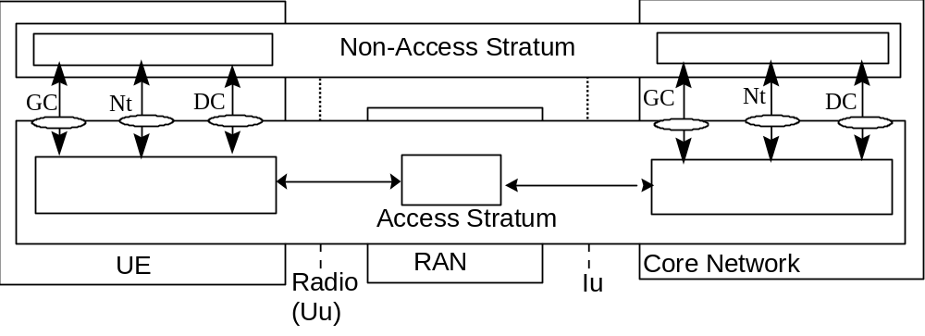
Figure 1: Assumed TD-SCDMA Architecture

Radio interface protocol architecture

Overall protocol structure
The radio interface is layered into three protocol layers:
- the physical layer (L1),
- the data link layer (L2),
- network layer (L3).
Layer 2 is split into two sublayers, Radio Link Control (RLC) and Medium Access Control (MAC).
Layer 3 and RLC are divided into Control (C-) and User (U-) planes.
In the C-plane, Layer 3 is partitioned into sublayers where the lowest sublayer, denoted as Radio Resource Control (RRC), interfaces with layer 2. The higher layer signalling such as Mobility Management (MM) and Call Control (CC) are assumed to belong to the non-access stratum, and therefore not in the scope of 3GPP TSG RAN and CWTS. On the general level, the protocol architecture is similar to the current ITU-R protocol architecture, ITU-R M.1035.
Figure 2 shows the radio interface protocol architecture. Each block in Figure 2 represents an instance of the respective protocol. Service Access Points (SAP) for peer-to-peer communication are marked with circles at the interface between sublayers. The SAP between MAC and the physical layer provides the transport channels (cf. Sec. 5.2.1.1). The SAPs between RLC and the MAC sublayer provide the logical channels (cf. Sec. 5.3.1.1.1). In the C-plane, the interface between RRC and higher L3 sublayers (CC, MM) is defined by the General Control (GC), Notification (Nt) and Dedicated Control (DC) SAPs.
Also shown in the figure are connections between RRC and MAC as well as RRC and L1 providing local inter-layer control services. An equivalent control interface exists between RRC and the RLC sublayer. These interfaces allow the RRC to control the configuration of the lower layers. For this purpose separate Control SAPs are defined between RRC and each lower layer (RLC, MAC, and L1). It is assumed that for RLC and MAC one Control SAP each is provided per UE.
[Note: Control of RLC entities in C and U planes needs to be clarified further. Also, the multiplicity of Control SAPs (necessity of one SAP per UE) at the RAN side may need to be reconsidered.]
The RLC sublayer provides ARQ functionality closely coupled with the radio transmission technique used. There is no difference between RLC instances in C and U planes.
The RAN can be requested by the CN to prevent all loss of data (i.e. independently of the handovers on the radio interface), as long as the Iu connection point is not modified. This is a basic requirement to be fulfilled by the RAN retransmission functionality as provided by the RLC sublayer.
However, in case of the Iu connection point is changed (e.g. SRNS relocation, streamlining), the prevention of the loss of data may not be guaranteed autonomously by the RAN but would rely on some functions in the CN. In this case, a mechanism to achieve the requested QoS may require support from the CN. Such mechanisms to protect from data loss due to SRNS relocation or streamlining are for further study.

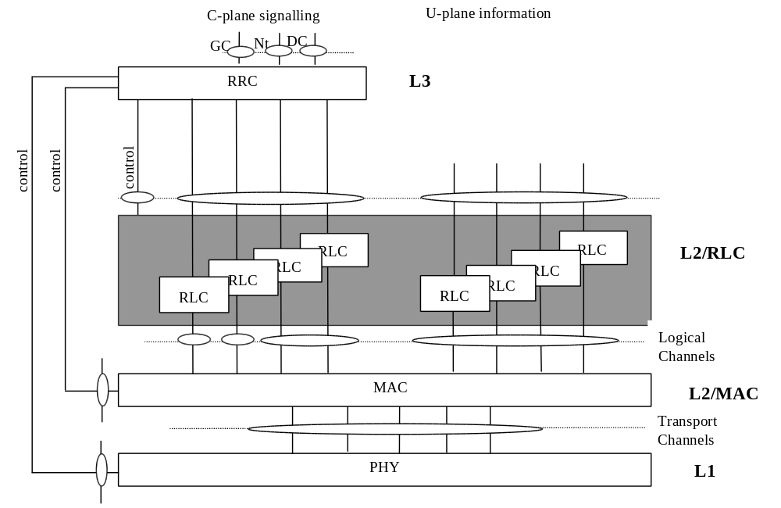
Figure 2: Radio Interface protocol architecture (Service Access Points marked by circles)Service access points and service primitives
Each layer provides services at Service Access Points (SAPs). A service is defined by a set of service primitives (operations) that a layer provides to upper layer(s).
Control services, allowing the RRC layer to control lower layers locally (i.e. not requiring peer-to-peer communication) are provided at Control SAPs (C-SAP). Note that C-SAP primitives can bypass one or more sublayers, see Figure 2.

In the radio interface protocol specifications, the following naming conventions for primitives shall be applicable:
- Primitives provided by SAPs between adjacent layers shall be prefixed with the name of the service-providing layer, i.e. PHY, MAC or RLC.
- Primitives provided by Control SAPs, in addition to the name of the service-providing layer, shall be prefixed with a “C”, i.e. CPHY, CMAC or CRLC.
This principle leads to the following notations, where <Type> corresponds to request, indication, response or confirm type of primitives:

Primitives between PHY and MAC:
PHY- <Generic name> – <Type>

Primitives between PHY and RRC (over C-SAP):
CPHY- <Generic name> - <Type>

Primitives between MAC and RLC:
MAC- <Generic name> - <Type>

Primitives between MAC and RRC (over C-SAP):
CMAC- <Generic name> - <Type>

Primitives between RLC and non-access stratum, and between RLC and RRC for data transfer:
RLC- <Generic name> - <Type>

Primitives between RLC and RRC for control of RLC (over C-SAP):
CRLC- <Generic name> – <Type>

Layer 1 Services and Functions
This section shall provide an overview on services and functions provided by the physical layer. A detailed description of Layer 1 general requirements can be found in CWTS TS C002 [10].

L1 Services
The physical layer offers information transfer services to MAC and higher layers. The physical layer transport services are described by how and with what characteristics data are transferred over the radio interface. An adequate term for this is ‘Transport Channel’.

Transport channels
A general classification of transport channels is into two groups:
- common transport channels (where there is a need for inband identification of the UEs when particular UEs are addressed) and
- dedicated transport channels (where the UEs are identified by the physical channel, i.e. code, time slot and frequency for TDD.
Common transport channel types are (a more detailed description can be found in [10]):
- Random Access Channel (RACH)
A contention based uplink channel used for transmission of relatively small amount of data, e.g. for initial access or non-realtime dedicated control or traffic data.
- ODMA Random Access Channel (ORACH)
A contention based channel used in relaylink.
- Forward Access Channel (FACH)
Common downlink channel with closed-loop power control used for transmission of relatively small amount of data.
- Downlink Shared Channel (DSCH)
A downlink channel shared by several UEs carrying dedicated control or traffic data.

- Uplink Shared Channel (USCH)
An uplink channel shared by several UEs carrying dedicated control or traffic data.
- Broadcast Channel (BCH)
A downlink channel used for broadcast of system information into an entire cell.
- Synchronization Channel (SCH)
A downlink channel used for broadcast of synchronization information into an entire cell.
- Paging Channel (PCH)
A downlink channel used for broadcast of control information into an entire cell allowing efficient UE sleep mode procedures. Currently identified information types are paging and notification. Another use could be CWTS notification of change of BCCH information.
Dedicated transport channel types are:
- Dedicated Channel (DCH)
A channel dedicated to one UE used in uplink or downlink.
- ODMA Dedicated Channel (ODCH)
A channel dedicated to one UE used in relaylink.
[Editors Note: ODMA in TD-SCDMA is optional.]

To each transport channel, there is an associated Transport Format (for transport channels with a fixed or slow changing rate) or an associated Transport Format Set (for transport channels with fast changing rate). A Transport Format is defined as a combination of encodings, interleaving, bit rate and mapping onto physical channels (see [4] and [10] for details). A Transport Format Set is a set of Transport Formats. E.g., a variable rate DCH has a Transport Format Set (one Transport Format for each rate), whereas a fixed rate DCH has a single Transport Format.

L1 Functions
The physical layer performs the following main functions:
- Macrodiversity distribution/combining and handover execution
- Error detection on transport channels and indication to higher layers
- FEC encoding/decoding and interleaving/deinterleaving of transport channels
- Multiplexing of transport channels and demultiplexing of coded composite transport channels
- Rate matching
- Mapping of coded composite transport channels on physical channels
- Power weighting and combining of physical channels
- Modulation and spreading/demodulation and despreading of physical channels
- Frequency and time (chip, bit, slot, frame) synchronization
- Measurements and indication to higher layers (e.g. FER, SIR, interference power, transmit power, etc.)
- Closed-loop power control
- Open- and closed-loop synchronization control
- Beamforming for both uplink and downlink
- User positioning
- RF processing

Layer 2 Services and Functions

MAC Services and Functions
This sections provides an overview on services and functions provided by the MAC sublayer. A detailed description of the MAC protocol is given in CWTS TS C201 [11].

MAC Services to upper layers
- Data transfer. This service provides unacknowledged transfer of MAC SDUs between peer MAC entities. This service does not provide any data segmentation. Therefore, segmentation/reassembly function should be achieved by upper layer.
- Reallocation of radio resources and MAC parameters. This service performs on request of RRC execution of radio resource reallocation and change of MAC parameters, i.e. reconfiguration of MAC functions such as change of identity of UE, change of transport format (combination) sets, change of transport channel type. resource allocation can be handled by the MAC autonomously.
- Reporting of measurements. Local measurements such as traffic volume, quality indication, MAC status indication, [other MAC measurements tbd.], are reported to RRC.

The following potential services are regarded as further study items:
- Allocation/deallocation of radio resources. Indication to RRC that allocation/deallocation of a MAC bearer is required. resource allocation can alternatively be performed by the MAC autonomously.

Logical channels
The MAC layer provides data transfer services on logical channels. A set of logical channel types is defined for different kinds of data transfer services as offered by MAC. Each logical channel type is defined by what type of information is transferred.
A general classification of logical channels is into two groups:
- Control Channels (for the transfer of control plane information)
- Traffic Channels (for the transfer of user plane information)
The configuration of logical channel types is depicted in Figure 3.


Figure 3: Logical channel structure

Control Channels
Control channels are used for transfer of control plane information only.
Synchronization Control Channel (SCCH)
A downlink channel for broadcasting synchronization information
Broadcast Control Channel (BCCH)
A downlink channel for broadcasting system control information. The BCCH may be further divided into two types, BCCH-Constant (BCCH-C) and BCCH-Variable (BCCH-V). BCCH-C would then transmit relatively many layer 3 information elements, which do not change, except for change of system information. BCCH-V would transmit layer 3 information elements which change frequently and which a UE has to receive in short time (e.g. downlink power level, uplink interference level, etc). The split of BCCH is FFS.

Paging Control Channel (PCCH)
A downlink channel that transfers paging information. This channel is used when the network does not know the location cell of the UE, or, the UE is in the cell connected state (utilizing UE sleep mode procedures).

Common Control Channel (CCCH)
Bi-directional channel for transmitting control information between network and UEs. This channel is commonly used by the UEs having no RRC connection with the network.

Dedicated Control Channel (DCCH)
A point-to-point bi-directional channel that transmits dedicated control information between a UE and the network. This channel is established through RRC connection setup procedure.

ODMA Common Control Channel (OCCCH)
Bi-directional channel for transmitting control information between UEs.

ODMA Dedicated Control Channel (ODCCH)
A point-to-point bi-directional channel that transmits dedicated control information between UEs. This channel is established through RRC connection setup procedure.

Traffic Channels
Traffic channels are used for the transfer of user plane information only.
Dedicated Traffic Channel (DTCH)
A Dedicated Traffic Channel (DTCH) is a point-to-point channel, dedicated to one UE, for the transfer of user information. A DTCH can exist in both uplink and downlink.

ODMA Dedicated Traffic Channel (ODTCH)
A ODMA Dedicated Traffic Channel (ODTCH) is a point-to-point channel, dedicated to one UE, for the transfer of user information between UE’s. A ODTCH exists in relaylink.

Common Traffic Channel (CTCH)
A point-to-multipoint unidirectional channel for transfer of dedicated user information for all or a group of specified UEs.
[Note: This channel type is agreed for support of Short Message Service-Cell Broadcast. Whether or not this logical channel shall also be employed for support of high-rate multicast services is FFS.]

Mapping between logical channels and transport channels
The following connections between logical channels and transport channels exist:
- SCCH is connected to SCH
- BCCH is connected to BCH
- PCCH is connected to PCH
- CCCH is connected to RACH and FACH
- DCCH and DTCH can be connected to either RACH and FACH, to CPCH and FACH, to RACH and DSCH, to DCH and DSCH, or to a DCH.
- DTCH can be connected to either RACH and FACH, to RACH and DSCH, to DCH and DSCH, to a DCH, or to USCH
- CTCH can be connected to DSCH, FACH or BCH (FFS.)
[
- ODCCH, OCCCH and ODTCH can be connected to ORACH, ODCCH and ODTCH can be connected to ODCH.

(Editor’s Note: The use of uplink synchronization within ODMA mode, e.g. between Root ODMA relay node and ODMA relay node, between two DMA relay node, between DMA relay node and Gateway ODMA relay node, should be also capable. The uplink synchronization used for ODMA mode is FFS.)

- DCCH can be connected to either RACH and FACH, to RACH and DSCH, to DCH and DSCH, to a DCH, or to USCH.
The mappings as seen from the UE and RAN sides are shown in Figure 4 and Figure 5 respectively. Figure 6
illustrates the mapping from the UE in relay operation. Note that ODMA logical channels and transport channels are employed only in relaylink transmissions (i.e. not used for uplink or downlink transmissions on the UE-RAN radio interface).

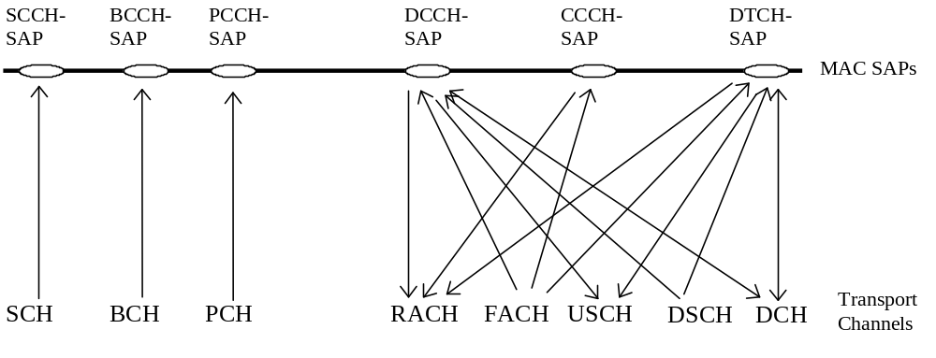
Figure 4: Logical channels mapped onto transport channels, seen from the UE side

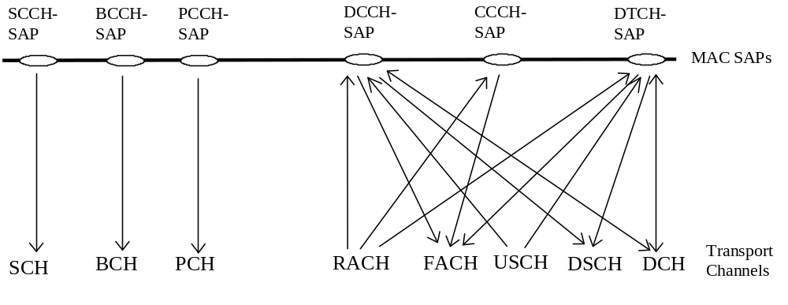
Figure 5: Logical channels mapped onto transport channels, seen from the RAN side

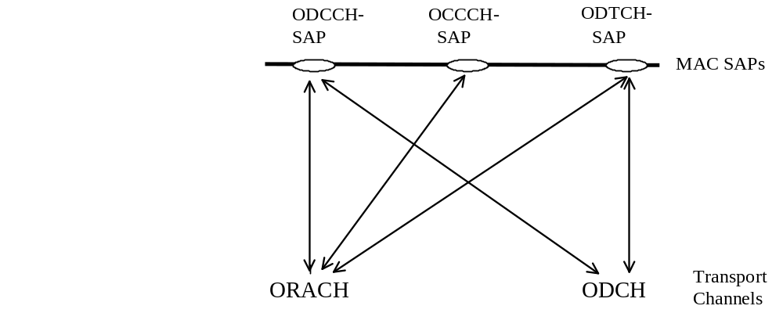
Figure 6: Logical channels mapped onto transport channels, seen from the UE side (relay only)

MAC functions
The functions of MAC include:
- Mapping between logical channels and transport channels. The MAC is responsible for mapping of logical channel(s) onto the appropriate transport channel(s).
- Selection of appropriate Transport Format for each Transport Channel depending on instantaneous source rate. Given the Transport Format Combination Set assigned by RRC, MAC selects the appropriate transport format within an assigned transport format set for each active transport channel depending on source rate. The control of transport formats ensures efficient use of transport channels.
- Priority handling between data flows of one UE. When selecting between the Transport Format Combinations in the given Transport Format Combination Set, priorities of the data flows to be mapped onto the corresponding Transport Channels can be taken into account. Priorities are e.g. given by attributes of radio access bearer services and RLC buffer status. The priority handling is achieved by selecting a Transport Format Combination for which high priority data is mapped onto L1 with a “high bit rate” Transport Format, at the same time letting lower priority data be mapped with a “low bit rate” (could be zero bit rate) Transport Format. Transport format selection may also take into account transmit power indication from Layer 1.
- Priority handling between UEs by means of dynamic scheduling. In order to utilize the spectrum resources efficiently for bursty transfer, a dynamic scheduling function may be applied. Priority handling on common and shared transport channels is realized by MAC. Note that for dedicated transport channels, the equivalent of the dynamic scheduling function is implicitly included as part of the reconfiguration function of the RRC sublayer.
[Note:this function is FFS]
- Priority handling between data flows of several users on the the DSCH and FACH

- Scheduling of broadcast, paging and notification messages. This function provides mechanisms for efficient transfer of broadcast, paging and notification messages by means of appropriate scheduling and repetition of the messages.
- Identification of UEs on common transport channels. When a particular UE is addressed on a common downlink channel, or when a UE is using the RACH, there is a need for inband identification of the UE. Since the MAC layer handles the access to, and multiplexing onto, the transport channels, the identification functionality is naturally also placed in MAC.
- Multiplexing/demultiplexing of higher layer PDUs into/from transport blocks delivered to/from the physical layer on common transport channels. MAC should support service multiplexing for common transport channels, since the physical layer does not support multiplexing of these channels.
- Multiplexing/demultiplexing of higher layer PDUs into/from transport block sets delivered to/from the physical layer on dedicated transport channels. The MAC allows service multiplexing for dedicated transport channels. This function can be utilized when several upper layer services (e.g. RLC instances) can be mapped efficiently on the same transport channel. In this case the identification of multiplexing is contained in the MAC protocol control information.
- Traffic volume monitoring. Measurement of traffic volume on logical channels and reporting to RRC. Based on the reported traffic volume information, RRC performs transport channel switching decisions.
- Routing of higher layer signalling. This function performs the mapping of higher layer signalling messages to the appropriate transport channel. resource allocation is performed by the MAC autonomously.
- Maintenance of a MAC signalling connection between peer MAC entities. This function supports unacknowledged transfer of MAC-internal messages between peer MAC entities. A MAC signalling connection is required.
- Monitoring the links of the assigned resources. This function provides means for monitoring link quality (used by MAC for DCA).
- Dynamic Transport Channel type switching. Execution of the switching between common and dedicated transport channels based on a switching decision derived by RRC.

The following potential functions are regarded as further study items:
- Constrained execution of open loop power control algorithms. This function establishes layer 1 power levels within the constraints of open loop power control set by RRC.
- [Note: Details of this function need to be clarified.]Processing of messages received at common control channels. This function is applied to support a data transfer on common control channels to support MAC operation (needed for fast DCA details are FFS.).
- Successive Transmission on RACH. When the mobile station continues to transmit the succeeding (second or more) radio frames because the message length is longer than a radio frame, the transmission timing offset, the RACH spreading code and signature shall be determined as follows: The transmission timing offset (frame and/or slot) shall be determined pseudo-randomly. The RACH spreading code and the signature of the succeeding radio frame can be determined pseudo-randomly. The same RNTI shall be used as in the previous radio frame (for the radio frames belonging to the same higher layer PDU).
[Note: This function requires further clarification. Contributions are invited.]
- Ciphering. This function prevents unauthorized acquisition of data.
[Note: Ciphering is considered as further study item. This includes consideration where it is applied, for instance on MAC, RLC, or elsewhere, cf. Sec. 8.]

- Access Service Class selection for RACH transmission. The RACH resources (i.e. access slots and preamble signatures) may be divided between different Access Service Classes in order to provide different priorities of RACH usage. This function selects, based upon the type of data to be transmitted, the RACH parameters in accordance with the Service Access Class assignment.
- Supports inband signalling (e.g. for AMR mode adaptation)

[Note: This function may support admission control. Its impact on BCCH capacity and its effects on RACH interference, retransmission and back-off time remains ffs.]

RLC Services and Functions
This section provides an overview on services and functions provided by the RLC sublayer. A detailed description of the RLC protocol is given in CWTS TS C202 [12].

Services provided to the upper layer

- RLC connection establishment/release. This service performs establishment/release of RLC connections.
- Transparent data transfer. This service transmits higher layer PDUs without adding any protocol information, possibly including segmentation/reassembly functionality.
- Unacknowledged data transfer. This service transmits higher layer PDUs without guaranteeing delivery to the peer entity. The unacknowledged data transfer mode has the following characteristics:
- Detection of erroneous data: The RLC sublayer shall deliver only those SDUs to the receiving higher layer that are free of transmission errors by using the sequence-number check function.
- Unique delivery: The RLC sublayer shall deliver each SDU only once to the receiving upper layer using duplication detection function.
- Immediate delivery: The receiving RLC sublayer entity shall deliver a SDU to the higher layer receiving entity as soon as it arrives at the receiver.

- Acknowledged data transfer. This service transmits higher layer PDUs and guarantees delivery to the peer entity. In case RLC is unable to deliver the data correctly, the user of RLC at the transmitting side is notified. For this service, both in-sequence and out-of-sequence delivery are supported. In many cases a higher layer protocol can restore the order of its PDUs. As long as the out-of-sequence properties of the lower layer are known and controlled (i.e. the higher layer protocol will not immediately request retransmission of a missing PDU) allowing out-of-sequence delivery can save memory space in the receiving RLC. The acknowledged data transfer mode has the following characteristics:
- Error-free delivery: Error-free delivery is ensured by means of retransmission. The receiving RLC entity delivers only error-free SDUs to the higher layer.
- Unique delivery: The RLC sublayer shall deliver each SDU only once to the receiving upper layer using duplication detection function.
- In-sequence delivery: RLC sublayer shall provide support for in-order delivery of SDUs, i.e., RLC sublayer should deliver SDUs to the receiving higher layer entity in the same order as the transmitting higher layer entity submits them to the RLC sublayer.
- Out-of-sequence delivery: Alternatively to in-sequence delivery, it shall also be possible to allow that the receiving RLC entity delivers SDUs to higher layer in different order than submitted to RLC sublayer at the transmitting side.
- QoS setting. The retransmission protocol shall be configurable by layer 3 to provide different levels of QoS. This can be controlled.
- Notification of unrecoverable errors. RLC notifies the upper layer of errors which cannot be resolved by RLC itself by normal exception handling procedures. e.g. by adjusting the maximum number of retransmissions according to delay requirements

The following service is regarded as further study item:
- Multicast delivery of higher layer messages. It is left for further study whether or not special functionality on RLC is needed for support of acknowledged transfer of user data to a specified group of UEs.
[Note: Contributions on this issue are invited.]
The length of a higher layer PDU (RLC SDU) can be variable up to the maximum length specified for each data transfer service [ffs.]. There is only a single RLC connection per Radio Access Bearer.

RLC Functions
- Connection Control. This function performs establishment, release, and maintenance of a RLC connection.
- Segmentation and reassembly. This function performs segmentation/reassembly of variable-length higher layer PDUs into/from smaller RLC Payload Units (PUs). One RLC PDU carries one PU or, in case header compression is applied several RLC PUs. The size oft the smallest retransmission unit shall be determined by the smallest possible bit rate. The RLC PDU size is adjustable to the actual set of transport formats.
- Header compression. The feature to include several Payload Units into one RLC PDU is referred to as RLC header compression. RLC header compression can be applied for acknowledged data transfer service. Its applicability shall be negotiable between network and UE. Application of RLC header compression is optional for the network but it shall be supported by the UE mandatory.
- Concatenation. If the contents of an RLC SDU does not fill an integer number of RLC PUs, the first segment of the next RLC SDU may be put into the RLC PU in concatenation with the last segment of the previous RLC SDU.
- Padding. When concatenation is not applicable and the remaining data to be transmitted does not fill an entire RLC PDU of given size, the remainder of the data field shall be filled with padding bits.
- Transfer of user data. This function is used for conveyance of data between users of RLC services. RLC supports acknowledged, unacknowledged and transparent data transfer. Transfer of user data is controlled by QoS setting.
- Error correction. This function provides error correction by retransmission (e.g. Selective Repeat, Go Back N, or a Stop-and-Wait ARQ) in acknowledged data transfer mode.
- In-sequence delivery of higher layer PDUs. This function preserves the order of higher layer PDUs that were submitted for transfer by RLC using the acknowledged data transfer service. If this function is not used, out-of-sequence delivery is provided.
- Duplicate Detection. This function detects duplicated received RLC PDUs and ensures that the resultant higher Layer PDU is delivered only once to the upper layer.
- Flow control. This function allows an RLC receiver to control the rate at which the peer RLC transmitting entity may send information.
- Sequence number check (Unacknowledged data transfer mode). This function guarantees the integrity of reassembled PDUs and provides a mechanism for the detection of corrupted RLC SDUs through checking sequence number in RLC PDUs when they are reassembled into a RLC SDU. A corrupted RLC SDU will be discarded.
- Protocol error detection and recovery. This function detects and recovers from errors in the operation of the RLC protocol.

The following potential function(s) are regarded as further study items:
- Suspend/resume function. Suspension and resumption of data transfer as in e.g. LAPDm (cf. GSM 04.05).
- Ciphering/deciphering. This function prevents unauthorized acquisition of data.
- Quick repeat (C plane only). This function provides mechanisms to transmit unacknowledged mode data PDUs several times.
[Note: Whether quick repeat function is performed by layer 3 or by RLC sublayer is FFS..]

Data flows through Layer 2
Data flows through layer 2 are characterized by the applied data transfer modes on RLC (acknowledged, unacknowledged and transparent transmission) in combination with the data transfer type on MAC, i.e. whether or not a MAC header is required. The case where no MAC header is required is referred to as “transparent” MAC transmission. Acknowledged and unacknowledged RLC transmissions both require a RLC header. In unacknowledged transmission, only one type of unacknowledged data PDU is exchanged between peer RLC entities In acknowledged transmission, both (acknowledged) data PDUs and control PDUs are exchanged between peer RLC entities.
The resulting different data flow cases are illustrated in Figures 7 - 10. On the level of detail presented here, differences between acknowledged and unacknowledged RLC transmission are not visible. Acknowledged and unacknowledged RLC transmission is shown as one case, referred to as non-transparent RLC.
[Note: The term “transparent transmission” is used here to characterize the case where a protocol, MAC or RLC, does not require any protocol control information (e.g. header). In transparent transmission mode, however, some protocol functions may still be applied. In this case an entity of the respective protocol must be present even when the protocol is transparent. For the RLC protocol the segmentation/reassembly function may be applied. This can be performed without segmentation header when a given higher layer PDU fits into a fixed number of RLC PDUs to be transferred in a given transmission time interval. In this case segmentation/reassembly follows predefined rules known to sending and receiving RLC entities. For instance in the user plane, the segmentation/reassembly function is needed for the case of real-time services using high and possibly variable bit rates. For such services higher layer PDUs shall be segmented into reasonably sized RLC PDUs of fixed length allowing efficient FCS error detection on the physical layer. The higher layer PDU can be reassembled by simply concatenating all RLC PDUs included in a transport block set as implied by the used transport format.]
Figure 7 and Figure 8 illustrate the data flows for transparent RLC with transparent and non-transparent MAC transmission, respectively.
Figure 9 and Figure 10 illustrate the data flows for non-transparent RLC with transparent and non-transparent MAC transmission, respectively.
For acknowledged RLC transmission mode, a single RLC PDU may include more than one segment (referred to as Payload Unit, cf. CWTS TS C202 [12] of RLC SDU. This feature, referred to as RLC header compression, is not shown here in the data flow.
A number of MAC PDUs shown in the figures shall comprise a transport block set. Note, however, that in all cases a transport block set must not necessarily match with a RLC SDU. The span of a transport block set can be smaller or larger than a RLC SDU.
Each mapping between a logical channel and a transport channel as defined in Figure 4 and Figure 5 in combination with the respective RLC transmission mode implies a certain data flow which is specified on a general level in the following.

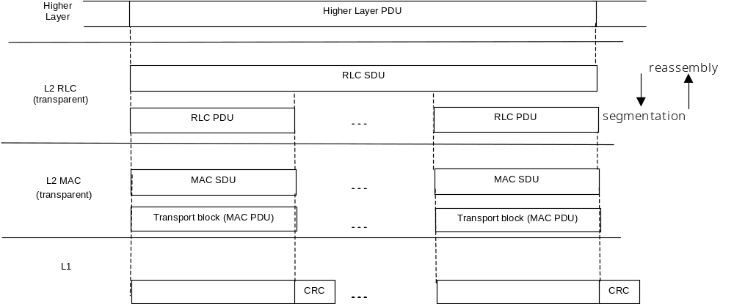
Figure 7: Data flow for transparent RLC and MAC

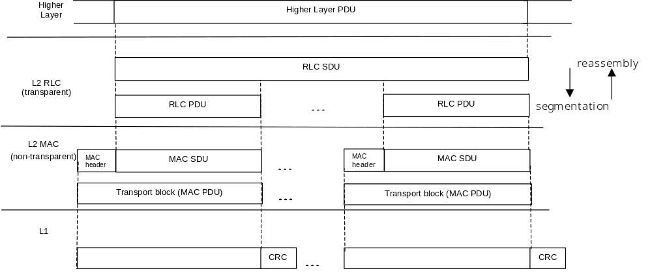
Figure 8: Data flow for transparent RLC and non-transparent MAC

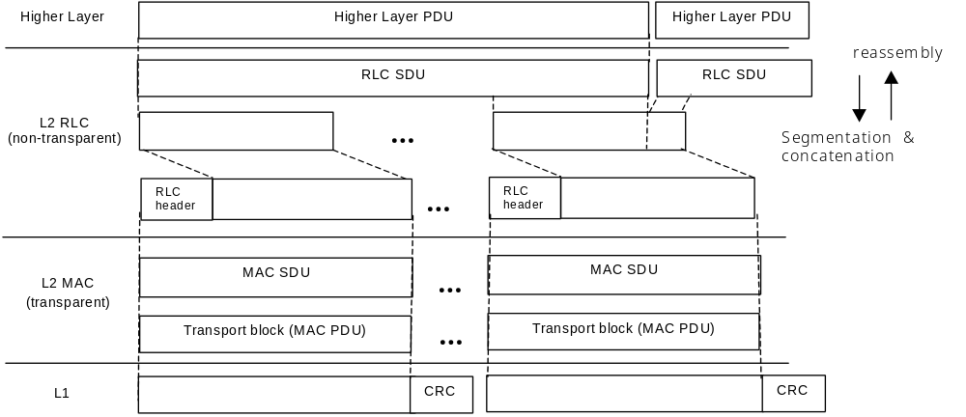
Figure 9: Data flow for non-transparent RLC and transparent MAC

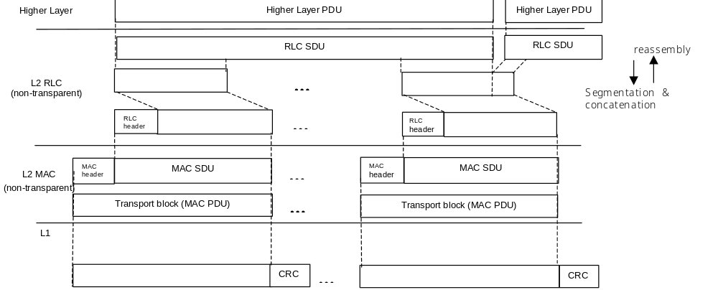
Figure 10: Data flow for non-transparent RLC and MAC

Data flow for BCCH mapped to BCH (FFS.)
Regarding the mapping of RRC PDUs into RLC PDUs two alternatives can be considered:
- All RRC PDUs transmitted on BCCH have a fixed length and fit into one (or a fixed number) of RLC PDUs (and, equivalently, MAC PDUs, as defined by the transport format). For this type of segmentation no RLC header is needed, i.e. the transparent data transfer mode of RLC is applied.
- RRC PDUs do not fit to the size of a fixed number of RLC PDUs. In this case the unacknowledged RLC transfer mode must be applied, since segmentation/reassembly requires a RLC header for segmentation sequence control.

A MAC header is needed only if multiple BCCH logical channels are mapped onto a BCH.
If the transparent RLC transfer mode is applied (above option (i)), depending on whether the MAC header is needed or not, either the data flow Figure 7 or Figure 8 is applicable. If the unacknowledged RLC transfer mode is applied (above option (ii)), depending on whether the MAC header is needed or not, either the data flow Figure 9 or Figure 10 is applicable.
[Note: It is expected that some of the above mentioned options can be removed when details of the BCCH have been specified.]

Data flow for PCCH mapped to PCH (FFS.)
Same data flow is applicable as for BCCH mapped to BCH. A MAC header is needed only if multiple PCCH logical channels are mapped onto a single PCH.

Data flow for SCCH mapped to SCH (FFS.)
Same data flow is applicable as for BCCH mapped to BCH. Applied in TDD mode only. A MAC header is not needed. The data flow shown in Figure 7 or Figure 9 applies, depending on applied RLC transmission mode.

Data flow for CCCH mapped to FACH/RACH (FFS)
For CCCH, transparent or unacknowledged transmission mode on RLC is employed. A MAC header may be used for logical channel identification (CCCH, DCCH, DTCH). When no MAC header is used, CCCH must be the only channel mapped to RACH/FACH. If the transparent RLC transfer mode is applied, depending on whether the MAC header is needed or not, either the data flow Figure 7 or Figure 8 is applicable. If the unacknowledged RLC transfer mode is applied, depending on whether the MAC header is needed or not, either the data flow Figure 9 or Figure 10 is applicable.
[Note: It might be possible that some of the above mentioned options can be removed when all messages carried on CCCH have been specified in detail.]

Data flow for DCCH mapped to FACH/RACH
For DCCH, both unacknowledged and acknowledged transmission mode on RLC is employed. A MAC header is mandatory for FACH/RACH carrying DCCH. The data flow shown in Figure 10 is applicable.

Data flow for DCCH mapped to DSCH
For DCCH, both unacknowledged and acknowledged transmission mode on RLC is employed. Whether or not a MAC header is needed for UE identification when DCCH is mapped to a DSCH is FFS., i.e. either the data flow in Figure 9 or Figure 10 is applicable.

Data flow for DTCH (non-transparent RLC) mapped to FACH/RACH
Mapping to FACH/RACH implies a DTCH with acknowledged (possibly also unacknowledged, FFS.) transmission on RLC. A MAC header is mandatory for FACH/RACH when carrying DTCH. The data flow shown in Figure 10 is applicable.

Data flow for DTCH (non-transparent RLC) mapped to DSCH
Mapping to DSCH implies a DTCH with acknowledged (possibly also unacknowledged, FFS.) transmission on RLC. Whether or not a MAC header is needed for UE identification when DTCH is mapped to a DSCH is FFS., i.e. either the data flow in Figure 9 or Figure 10 is applicable.

Data flow for DTCH (transparent RLC) mapped to DCH
Continuous DTCH data stream is segmented into transport blocks on RLC and mapped on a DCH transport channel on MAC. The transport block size is naturally implied by the data rate. Both RLC and MAC sublayers are transparent, i.e. no protocol control information is added, when no multiplexing of DTCH on MAC is applied. The data flow shown in Figure 7 is applicable. If multiplexing on MAC is performed, a MAC header is needed, and Figure 8 applies.

Data flow for DTCH (non-transparent RLC) mapped to DCH
In this case acknowledged or unacknowledged transmission on RLC is applied. A MAC header is needed only if multiple DTCH logical channels are multiplexed in MAC before mapping to a DCH, i.e. either the data flow in Figure 9 or Figure 10 is applicable.

Data flow for DCCH mapped to DCH
In this case non-transparent transmission mode on RLC is applied. A MAC header is needed only if DCCH and DTCH logical channels are multiplexed in MAC before mapping to a DCH, i.e. either the data flow in Figure 9 or Figure 10 is applicable.

Layer 3 - RRC Services and Functions
This sections provides an overview on services and functions provided by the RRC layer. A detailed description of the RRC protocol is given in 3GPP TS 25.331 [9] and CWTS TS 203 [13]. Examples of structured procedures involving RRC in Idle Mode and Connected Mode are described in 3GPP TS 25.303 [5], CWTS TS 003 [14], 3GPP TS 25.304 [6] and CWTS TS 004 [15], respectively.

RRC services

General Control
The GC SAP provides an information broadcast service. This service broadcasts information to all UEs in a certain geographical area. The basic requirements from such service are:
- It should be possible to broadcast non-access stratum information in a certain geographical area.
- The information is transferred on an unacknowledged mode link. Unacknowledged mode means that the delivery of the broadcast information can not be guaranteed (typically no retransmission scheme is used). It seems reasonable to use an unacknowledged mode link since the information is broadcast to a lot of UEs and since broadcast information often is repeated periodically.
- It should be possible to do repeated transmissions of the broadcast information (how it is repeated is controlled by the non-access stratum).
- The point where the UE received the broadcast information should be included, when the access stratum delivers broadcast information to the non-access stratum.

Notification
The Nt SAP provides paging and notification broadcast services. The paging service sends information to a specific UE(s). The information is broadcast in a certain geographical area but addressed to a specific UE(s). The basic requirements from such service are:
- It should be possible to broadcast paging information to a number of UEs in a certain geographical area.
- The information is transferred on an unacknowledged mode link. It is assumed that the protocol entities in non-access stratum handle any kind of retransmission of paging information.
The notification broadcast service broadcasts information to all UEs in a certain geographical. The basic requirements from this service are typically the same as for the information broadcast service of the GC SAP:
- It should be possible to broadcast notification information in a certain geographical area.
- The information is transferred on an unacknowledged mode link.

Dedicated Control
The DC SAP provides services for establishment/release of a connection and transfer of messages using this connection. It should also be possible to transfer a message during the establishment phase. The basic requirements from the establishment/release services are:
- It should be possible to establish connections (both point and group connections).
- It should be possible to transfer an initial message during the connection establishment phase. This message transfer has the same requirements as the information transfer service.
- It should be possible to release connections.
The information transfer service sends a message using the earlier established connection. According to [1] it is possible to specify the quality of service requirements for each message. A finite number of quality of service classes will be specified in [1], but currently no class has been specified. In order to get an idea of the basic requirements, the CC and MM protocols in GSM are used as a reference. A GSM based core network is chosen since it is one main option for UMTS. Considering the existing GSM specification of CC and MM the basic requirements from the information transfer service are (these are some the services provided by RR and the data link layer in GSM):
- Acknowledged mode link for transfer of messages
This acknowledged mode link guarantees that the CC and MM messages are transferred to the corresponding side. Acknowledged mode means that the delivery of upper layer information can be guaranteed (some kind of retransmission scheme is used). A connection between two DC SAPs using an acknowledged mode link is called signalling connection. This link should also guarantee that no messages are lost or duplicated during handover.
- Preserved message order
The order of the transferred messages is preserved.
- Priority handling
If SMS messages should be transported through the control plane it should be possible to give higher priority to signalling messages.
The CC and MM protocols also expect other services, which can not be supported by the current primitives of the DC SAP, e.g. indication of radio link failure.

RRC functions
The Radio Resource Control (RRC) layer handles the control plane signalling of Layer 3 between the UEs and RAN. The RRC performs the following functions:
- Broadcast of information provided by the non-access stratum (Core Network). The RRC layer performs system information broadcasting from the network to all UEs. The system information is normally repeated on a regular basis. This function supports broadcast of higher layer (above RRC) information. This information may be cell specific or not. As an example RRC may broadcast Core Network location service area information related to some specific cells.
- Broadcast of information related to the access stratum. The RRC layer performs system information broadcasting from the network to all Ues This function supports broadcast of typically cell-specific information.
- Broadcast of ODMA relay node neighbor information. The RRC layer performs probe information broadcasting to allow ODMA routeing information to be collected.
- Establishment, maintenance and release of an RRC connection between the UE and RAN. The establishment of an RRC connection is initiated by a request from higher layers at the UE side to establish the first Signalling Connection for the UE. The establishment of an RRC connection includes an optional cell re-selection, an admission control, and a layer 2 signalling link establishment. The release of an RRC connection can be initiated by a request from higher layers to release the last Signalling Connection for the UE or by the RRC layer itself in case of RRC connection failure. The RRC layer detects loss of RRC connection and releases resources assigned for the RRC connection in case of connection failure.
- Collating ODMA neighbour list and gradient information. The ODMA relay node neighbor lists and their respective gradient information will be maintaining by the RRC.
- Maintenance of number of ODMA relay node neighbours. The RRC will adjust the broadcast powers used for probing messages to maintain the desired number of neighbors.
- Establishment, maintenance and release of a route between ODMA relay nodes. The establishment of an ODMA route and RRC connection based upon the routing algorithm.
- Interworking between the Gateway ODMA relay node and the UTRAN. The RRC layer will control the interworking with the standard TDD or FDD communication link between the Gateway ODMA relay node and the UTRAN.
- Establishment, reconfiguration and release of Radio Access Bearers. The RRC layer can, on request from higher layers, perform the establishment, reconfiguration and release of radio access bearers in the user plane. A number of radio access bearers can be established to an UE at the same time. At establishment and reconfiguration, the RRC layer performs admission control and selects parameters describing the radio access bearer processing in layer 2 and layer 1, based on information from higher layers.
- Assignment, reconfiguration and release of radio resources for the RRC connection. The RRC layer handles the assignment of radio resources (e.g. codes) needed for the RRC connection including needs from both the control and user plane. The RRC layer may reconfigure radio resources during an established RRC connection. This function includes coordination of the radio resource allocation between multiple radio bearers related to the same RRC connection. RRC controls the radio resources in the uplink and downlink such that UE and RAN can communicate using unbalanced radio resources (asymmetric uplink and downlink). RRC signals to the UE to indicate resource allocations for purposes of handover to GSM or other radio systems.
- RRC connection mobility functions. The RRC layer performs evaluation, decision and execution related to RRC connection mobility during an established RRC connection, such as handover, preparation of handover to GSM or other systems, cell re-selection and cell/paging area update procedures, based on e.g. measurements done by the UE.
- Paging/notification. The RRC layer can broadcast paging information from the network to selected UEs. Paging and notification can be requested by higher layers on the network side. The RRC layer can also initiate paging during an established RRC connection.
- Routing of higher layer PDUs. This function performs at the UE side routing of higher layer PDUs to the correct higher layer entity, at the RAN side to the correct RANAP entity.
- Control of requested QoS. This function shall ensure that the QoS requested for the radio access bearers can be met. This includes the allocation of a sufficient number of radio resources. The exact requirements on RRC to support this function are FFS.
- UE measurement reporting and control of the reporting. The measurements performed by the UE are controlled by the RRC layer, in terms of what to measure, when to measure and how to report, including both UMTS air interface and other systems. The RRC layer also performs the reporting of the measurements from the UE to the network.
- Control of ciphering. The RRC layer provides procedures for setting of ciphering (on/off) between the UE and RAN.
- Slow DCA. Allocation of preferred radio resources based on long-term decision criteria.
- Contention resolution. The RRC handles reallocations and releases of radio resources in case of collisions indicated by lower layers.
- Arbitration of radio resources on uplink DCH. This function controls the allocation of radio resources on uplink DCH on a fast basis, using a broadcast channel to send control information to all involved users. [Note: This function is implemented in the CRNC. Details are FFS.]
- Initial cell selection and re-selection in idle mode. Selection of the most suitable cell based on idle mode measurements and cell selection criteria.
- User positioning

The following functions are regarded as further study items:
- Arbitration of the radio resource allocation between the cells. This function shall ensure optimal performance of the overall RAN capacity.
[Note: Some clarification should be provided what exact requirements this function implies on the RRC protocol, beyond general radio resource optimization.]
- Congestion control. Further study item.

Interactions between RRC and lower layers in the C plane
The RRC protocol controls and signals the allocation of radio resources to the UE. RRC allows MAC to arbitrate between users and radio access bearers within the radio resource allocation. The RRC uses the measurements done by the lower layers to determine which radio resources that are available. Therefore it is a need for a measurement report from the UE RRC to the RAN RRC. Figure 11 illustrates the principle. The local control and local measurements reporting is handled through the control SAPs between RRC and the lower layers.
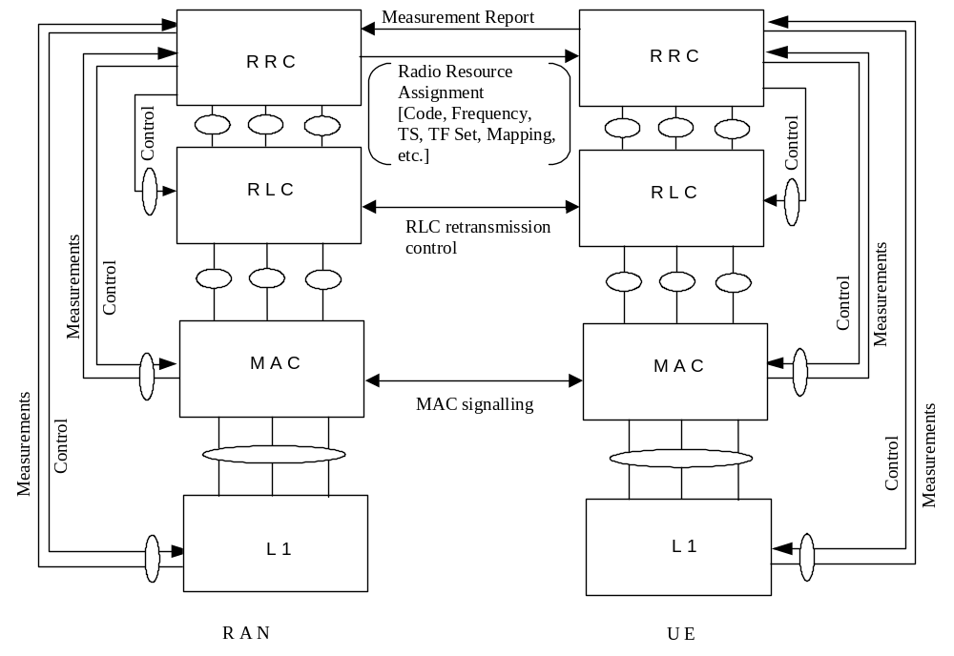
Figure 11: Interactions between RRC and lower layers

Protocol termination
This section specifies in which node of the RAN the radio interface protocols are terminated, i.e. where within RAN the respective protocol services are accessible.

Protocol termination for DCH
Figure 12 and Figure 13 show the protocol termination for DCH for the control and user planes, respectively. The part of physical layer terminating in the Serving RNC is the topmost macro-diversity combining and splitting function for the FDD mode. If no macrodiversity applies, the physical layer is terminated in Node B.
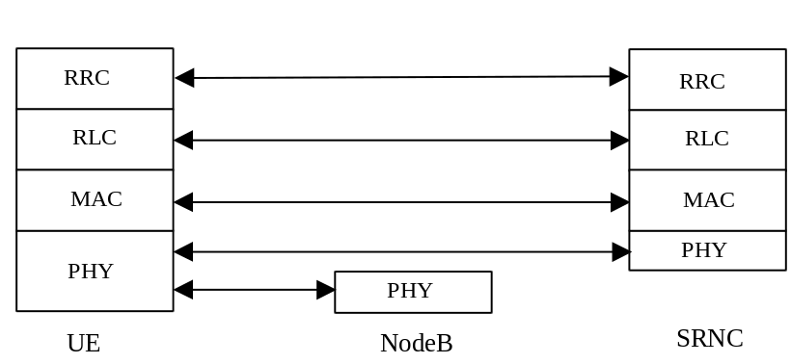
Figure 12: Protocol Termination for DCH, control plane
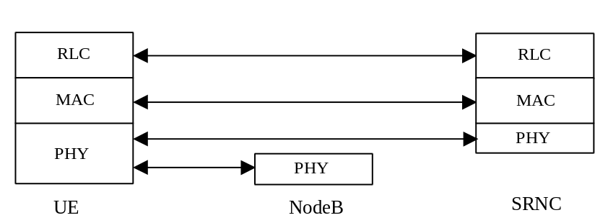
Figure 13: Protocol Termination for DCH, user plane

Protocol termination for RACH/FACH
Figure 14 and Figure 15 show the protocol termination for RACH/FACH for the control and user planes, respectively. Control plane termination refers to the case where RACH/FACH carry dedicated or common control information (i.e. CCCH or DCCH). User plane termination refers to the case where RACH/FACH carry user data (DTCH) (two alternatives cases, referred to as case B and C, are described in the Annex).
It is assumed that macrodiversity/soft handover is not applied for RACH/FACH. Therefore, the physical layer terminates in Node B. For RACH/FACH carrying DCCH, MAC is split between Controlling and Serving RNC. RLC, and in the C plane also RRC terminate in the Serving RNC. Since Iur can support common channel data streams, the users of that common channel can depend on different SRNCs. However, they depend on the same Controlling RNC. Therefore, for a given user, the Controlling RNC and the Serving RNC can be separate RNCs.
For RACH/FACH carrying CCCH, MAC, RLC and RRC are terminated in the RNC.
[Note: It is currently an open issue whether or not there are CCCH messages that need to be routed between Controlling and Serving RNC over Iur. If it is only the initial access message that is defined for CCCH, C-RNC and S-RNC are always identical and no routing would be needed. If messages such as “URA update”, “Cell update” and “RRC connection re-establishment” would be signalled on CCCH, routing of these messages on RRC level would need to be performed ]
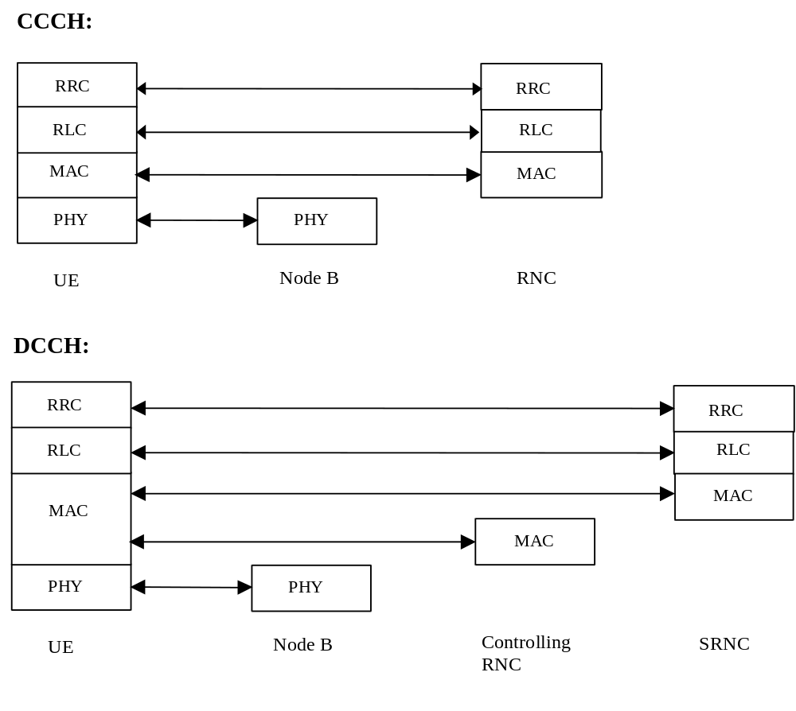
Figure 14: Protocol Termination for RACH/FACH, control plane
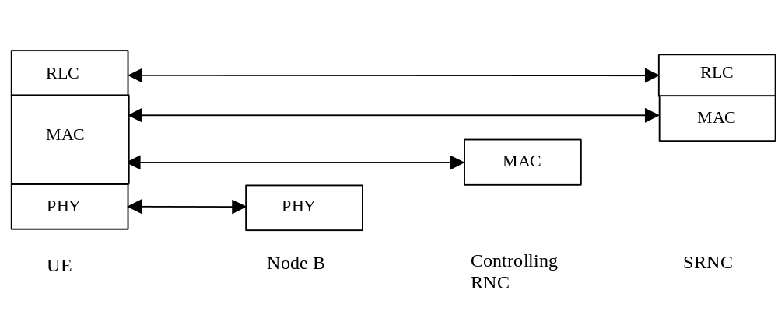
Figure 15: Protocol Termination for RACH/FACH, user plane

Protocol termination for DSCH

DSCH definition
The DSCH is a resource that exists in downlink only. It has only impact on the physical and transport channel levels, so there is no definition of shared channel in the logical channels provided by MAC.
The DSCH is a transport channel shared dynamically between several UEs. The DSCH is mapped to one or several physical channels such that a specified part of the downlink code tree is employed. For the DSCH no macrodiversity is applied, i.e. a specific DSCH is transmitted in a single cell only.
The following two DSCH cases are presently considered, in the following denoted as cases A and B:
Case A: The DSCH is defined is an extension to DCH transmission. DSCH related resource allocation is signalled utilizing the transport format indication field (TFI) that will be mapped to the TFCI of the associated DCH.
Case B: The DSCH is defined as a shared downlink channel for which resource allocation, including UE identification, is signalled on FACH or DSCH (by time/code multiples)
Interleaving for the DSCH may be applied over a multiplicity of radio frames. Nevertheless, here the basic case is considered where the interleaving is rectangular for a given MAC PDU, and equal to one radio frame . The framing is synchronised on the SCH.
In every radio frame, one or several codes can be used in the downlink. Therefore, the DSCH supports code multiplexing. MAC multiplexing shall not be applied within a radio frame, i.e. the whole radio frame for one code is assigned to a single UE. However, MAC multiplexing is allowed on a frame by frame basis, i.e. one code may be allocated to different UEs at each frame.
Transport blocks on the DSCH may be of constant size, so that the Transport Block Set may be derived from the code allocated to each UE on the DSCH.

Resource allocation and UE identification on DSCH
The principles of capacity allocation and UE identification on the DSCH are described in more detail below.
[Note: The two resource allocation methods of the cases A and B might be used simultaneously for one DSCH, i.e. some UEs may use an associated DSCH Control Channel and some UEs may use an associated DCH for resource allocation while transmitting data on the same DSCH. This option is FFS.]

Case A (UE requires a downlink TFCI on a DPCCH)
The TFCI of the dedicated physical channel may carry the information that a given code of the DSCH must be listened to by the UE. Fast power control can be applied per code based on the dedicated physical control channel, DPCCH.
Alternatively, a UE may be requested on the DCH to listen to a DSCH for a given period of time, and to decode the data so that the address of the destination UE can be decoded. This does not require more TFCI values because signalling is done in layers 2 and 3.

Case B (UE requires a FACH or DSCH)
In the case B UE requires a FACH or DSCH. It is time/code multiplexed on the downlink when DSCH is used. This time FACH or DSCH should convey the following information, which is modified every radio frame:
- Layer 1 information
- TPC bits for each UE which would have an uplink DCH without downlink DCH.
- Channelisation code allocated to each UE indicated relatively to the DSCH code entry point
- Layer 2 information
- Identity of the UEs who should receive information on the DSCH. The UE ID is allocated when a RAB is mapped onto a DSCH. Which UE ID is used to identify UE on the DSCH of each cell is FFS.

This concept allows to perform power control on the DSCH.

Model of DSCH in RAN
Figure 16 captures the working assumption on the Downlink Shared Channel (DSCH). The two RLCs point to logical channel (DTCH) specific RLC-entities of specific users while MAC refers to the provision of MAC sublayer functions for all users.
The MAC sublayer of a DSCH is split between the Controlling RNC and SRNC. For a given user, the RLC sublayer is terminated in its SRNC. Since Iur can support DSCH data streams, the users on that DSCH can depend on different SRNCs. For a given user, the Controlling RNC and the Serving RNC can be separate RNCs. The MAC in the network takes care of mapping downlink data either to a common channel (FACH, not shown in this figure), DCH or the DSCH.
Figure 16 is a Model of downlink shared channel (DSCH) in RAN . See CWTS TS C201 [13] for details on MAC architecture. In this example, the resource allocation on the DSCH is signalled on the FACH or DSCH for UE 1 and on the associated DCH for UE 2.

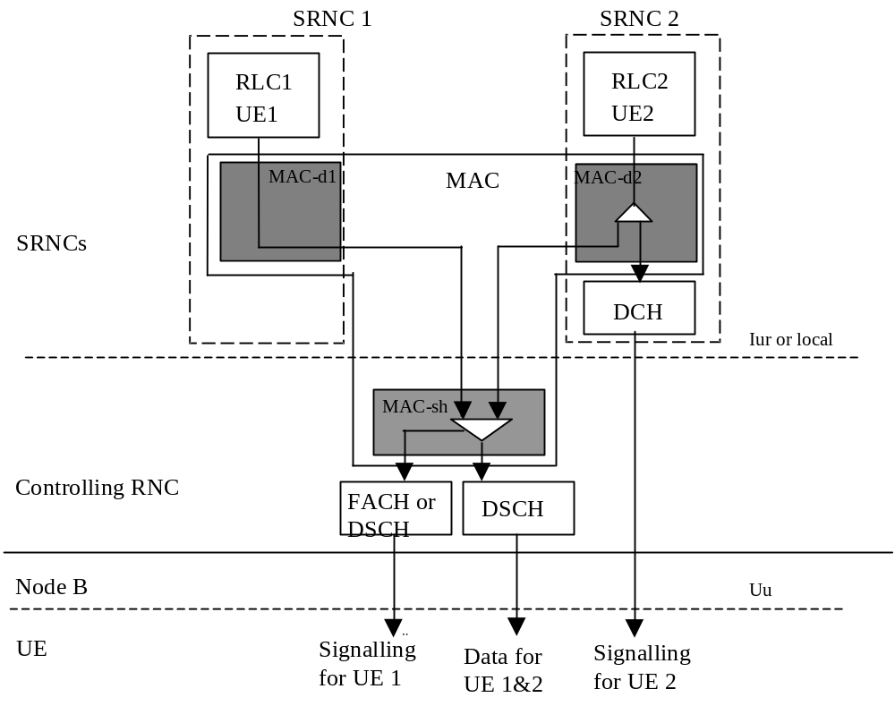
Figure 16: Model of downlink shared channel (DSCH) in RAN

Protocol termination
The protocol termination points for DSCH in control and user planes are presented in Figure 17 and Figure 18, respectively.

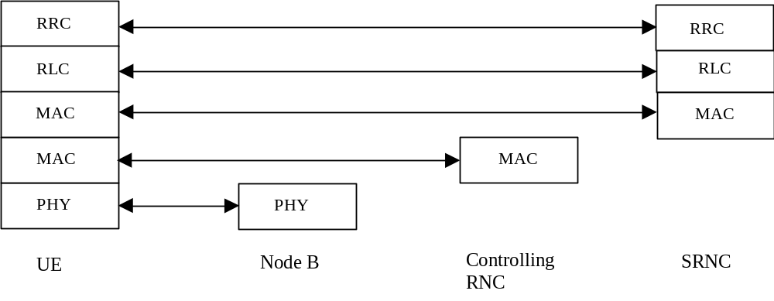
Figure 17: Protocol termination points for DSCH, control plane.
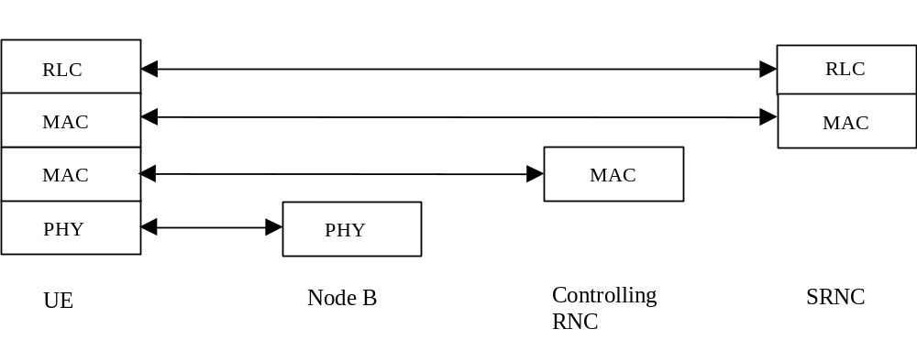
Figure 18: Protocol termination points for DSCH, user plane.

Protocol termination for transport channel of type BCH
System information on BCH can include information which is available only in Node B, and need to be updated very frequently (each 10-100 ms), such as uplink interference in the cell. Also, for the system information originating from the RNC, it is assumed that the updating of system information is at least one magnitude less (minutes) than the repetition frequency on the BCH (in the order of 1s). Protocol termination for the BCH shall therefore reside in the Node B, resulting in less signalling on Iub and lower processor load. Note that the RLC sublayer is transparent for this transport channel type.

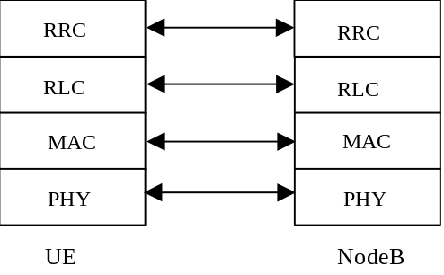
Figure 19: Protocol termination for BCH.

Protocol termination for transport channel of type PCH
In order to enable coordinated scheduling between PCH and FACH/DSCH the corresponding MAC scheduling functions shall be allocated in the same node (co-location of MAC-p, MAC-c and MAC-sh entities). Both MAC-sh and MAC-c are terminated in CRNC. Consequently, the MAC termination of PCH shall also be in CRNC. A natural implication is that RLC and RRC also are terminated in CRNC.
Note that the RLC sublayer is transparent for this channel.

[Note: Above termination of PCH has been agreed as working assumption. Some WG2 members however requested some more time for further consideration. The above assumption shall be confirmed before or at the next WG2 meeting. The previous solution is kept in the Annex as alternative PCH termination option.]
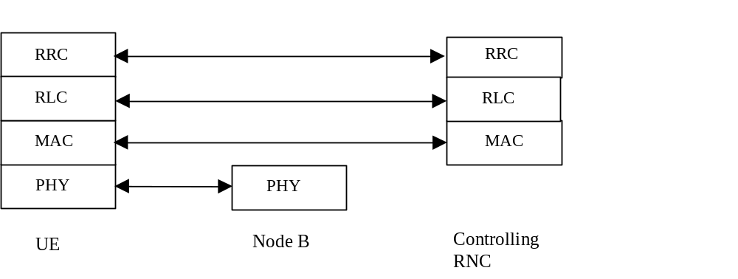
Figure 20: Protocol termination for PCH

Protocol termination for transport channel of type SCH
The SCH transport channel is used in TDD mode only. Protocol termination for SCH is the same as for BCH as shown in Figure 19.

Protocol termination for ODCH
Figure 21 and Figure 22 show the protocol termination for ODCH in the control and user planes, respectively.

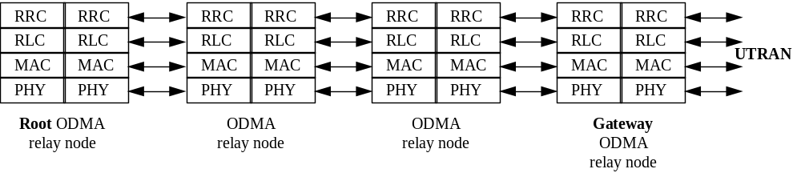
Figure 21: Protocol Termination for the ODCH in the Control Plane

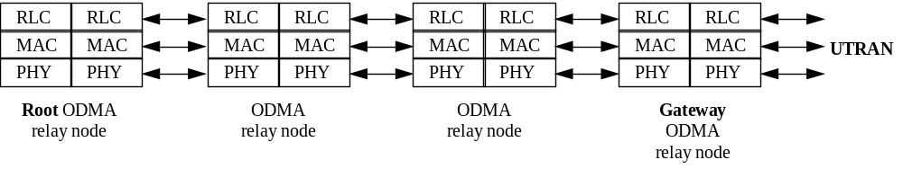
Figure 22: Protocol Termination for the ODCH in the User Plane

Note: The current mechanisms and procedures carried out by the RLC and the MAC for the DCH will require minor, subtle modifications to enable them to handle the ODCH.

Protocol termination for ORACH
The protocol termination for ORACH for the control and user planes are illustrated in Figure 23 and Figure 24, respectively. The shown ODMA relay nodes may be either UE_{R}, Seed, Root, or Gateway.

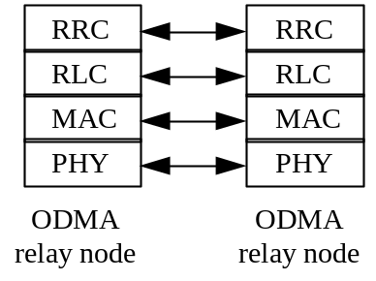
Figure 23: Protocol Termination for ORACH control plane

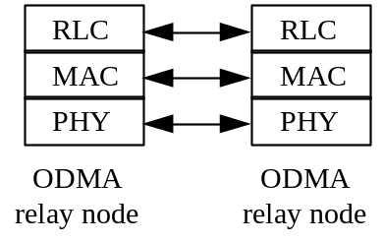
Figure 24: Protocol Termination for ORACH user plane

User Identification and RRC Connection Mobility

UE identification within RAN
A Radio Network Temporary Identity (RNTI) is used as an UE identifier on RACH/FACH by the MAC protocol, or on PCH by the RRC, when a RRC connection exists.
Definition of UE identifiers
Two types of RNTI exist. One is used within the Serving RNC and it is denoted by Serving RNC RNTI (s-RNTI), the other is used within C-RNC, when applicable, and it is denoted by Controlling RNC RNTI (c-RNTI).
s-RNTI is allocated for all UEs having a RRC connection. It is allocated by the Serving RNC and it is unique within the Serving RNC. s-RNTI is reallocated always when the Serving RNC for the RRC connection is changed and reallocated when the RRC connection is released.
In addition for each UE having an RRC connection, there is an identifier of its current serving RNC, which is denoted as S-RNC identifier. The S-RNC identifier together with s-RNTI is a unique identifier of the RRC connection within PLMN.
c-RNTI for an UE is allocated by each controlling RNC through which UE is able to communicate on DCCH. c-RNTI is unique within the allocating C-RNC. c-RNTI is always allocated when a new UE context is created to a RNC. Serving RNC is always aware of all c-RNTIs allocated for the UE.
Usage of UE identifiers
s-RNTI together with the S-RNC identifier is used as a UE identifier in cell update, URA update, RRC connection reestablishment and (RAN originated) paging messages and associated responses on the air interface. S-RNC identifier is used by Controlling RNC to route the received uplink messages towards the Serving RNC. For the initial access two different methods of identification, a random number and a unique core network identifier are under consideration.
c-RNTI is used as a UE identifier in all other DCCH/DTCH common channel messages on the air interface.

[Note: Initial access, when no RRC connection exists, needs further study. The following two methods could be applied: (i) The initial access message carried on RACH/FACH transport channels and CCCH logical channel includes a unique UE identity (e.g. TMSI + LAI). (ii) The initial access message includes a random number as temporary identity. The unique UE identity is then exchanged in a second phase after establishment of DCH transport channels on DCCH. In TDD mode, the first approach may imply initial access message length too large to be carried on RACH. Therefore the above second approach is preferred for TDD. In FDD mode, the first approach would be preferable. It is thus currently not decided whether the same or different initial access methods will need to be applied in FDD and TDD modes. Further contributions on this issue are invited. Also, it is FFS. whether messages with s-RNTI and RNC-ID will use the CCCH or the DCCH logical channel and whether the protocol layer providing the address field (and C-RNC routing) is MAC or RRC.]

A specific s-RNTI or c-RNTI (FFS.) is valid in several cells, thus decreasing the RNTI reallocation signalling for moving inactive packet data UE's.

UE connection to RAN
The different levels of UE connection to RAN are listed below:
- No signalling connection exist
The UE has no relation to RAN, only to CN. For data transfer, a signalling connection has to be established.
- Signalling connection exist
There is a RRC connection between UE and RAN. The UE position can be known on different levels:
- RAN Registration Area (RRA) level
The UE position is known on RAN registration area level. RRA is a specified set of cell which can be identified on the BCCH.
- Cell level
The UE position is known on cell level. Different channel types can be used for data transfer:
- Common transport channels (RACH/FACH),
- Dedicated transport channels (DCH);

UE modes
Two modes of operation are defined for the UE, idle mode and connected mode [5, 6,15,16].
After power on, the UE stays in idle mode until it transmits a request to establish an RRC connection. In idle mode the UE is identified by non-access stratum identities such as IMSI, TMSI and TLLI. In addition, the RAN has no own information about the individual idle mode UEs, and can only address e.g. all UEs in a cell or all UEs in a paging group.
The connected mode is entered when the RRC connection is established. The UE is assigned a radio network temporary identity (s-RNTI + S-RNC ID and possibly in addition c-RNTI) to be used as UE identity on common transport channels. [Note: The exact definition of RRC connection needs further refinement.]
The UE leaves the connected mode and returns to idle mode when the RRC connection is released or at RRC connection failure. [Note: whether UE power off causes RRC connection release and/or RRC connection failure is FFS.]
[Note: Other modes than idle mode and connected mode, such as separate mode(s) for the reception of point-to-multipoint information, are FFS.]

Ciphering ( FFS in CWTS)

Presently two solutions for the ciphering execution exist. Ciphering is performed either (a) always on MAC layer or (b) depending on RLC type (transparent vs. non-transparent) either on MAC or on RLC layer. In addition, integrity control on Common Control Channels is considered. (Introduction of a separate ciphering sublayer may be considered in case there are severe problems with these assumptions).

Any ciphering algorithm requires a sequence number as an input parameter. As sequence number, a UE frame number (UE FN) as defined in TS 25.401 [2] may be used when ciphering is performed in MAC layer. The UE FN is composed at least of a Connection Frame Number (CFN). The sequence number is composed at least of the RLC PDU sequence number when ciphering is performed in RLC. To meet the requirements for the length of frame number used for ciphering, a Hyper Frame Number (HFN), incremented at every completed cycle of the CFN, is added to the UE FN. With this solution, the length of the frame number broadcast in BCCH need not be as long as the length of frame number used for ciphering (which should be at least 32 bits).

A problem with regard to security risk, common for all proposed ciphering methods, is how to initialize the HFN.
In case of MAC ciphering, only one HFN is needed. In case of MAC and RLC ciphering, at least two HFNs (or equivalent counters) are needed.

Following requirements exists:
- Initialise the HFN before the ciphering is activated.
- Avoid to reuse the same SN value in input of the ciphering algorithm twice or more in a "short" time (especially with the same ciphering key, Kc). This reduces the security of the system.
A problem exists when a UE uses the same Kc (ciphering key) in two subsequent RRC connections. If in both connections the HFN is initialised to zero, the same inputs to the ciphering algorithm (FN and Kc) are used twice and the same ciphering mask may be reused in a relatively short period of time. This may occur also with a random initialisation of HFN. This is not 'secure' and should be avoided.

One possible solution to this is that when the RRC connection is released, the terminal (SIM card) stores the last HFN(s) used.
At a new RRC connection setup or at RRC connection re-establishment, UE initialises the HFN(s) to a value higher than the last used HFN(s) value, and transmits this/these to the SRNC, either in the RRC Connection Request message or in the first message after the RRC connection is established.
Depending on the requirements (e.g. how many successive RRC Connections can use the same ciphering key), it may be sufficient to use only the most significant bits of HFN in the re-initialization (and set LSBs implicitly to zero). This may be necessary at least if the HFN value needs to be included in the RRC Connection Request message.

Appendices

Annex A (informative): Protocol termination
This Annex describes protocol termination cases which have been excluded from the initial TD-SCDMA release. These cases are captured here for information. They potentially may be considered for future releases.

A.1 Alternative protocol termination for DCH
Figure 25 and Figure 26 show an alternative protocol termination case for DCH for the control and user planes, respectively, referred to as Case B. This case would be applicable when macrodiversity at RNC level is not applied, i.e. especially for DCH in the TDD mode.
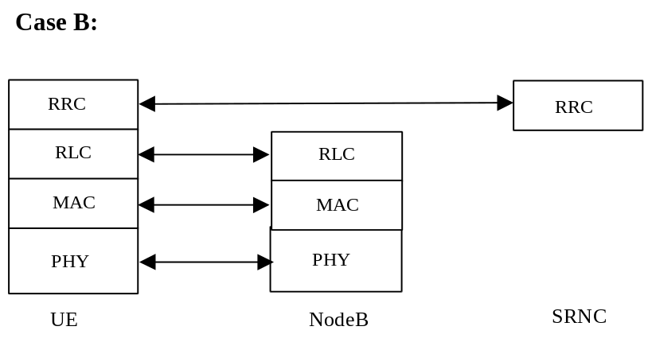
Figure 25: Protocol Termination for DCH, control plane
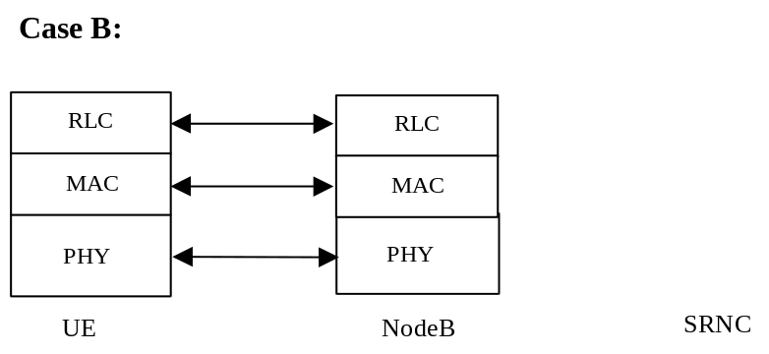
Figure 26: Protocol Termination for DCH, user plane

A.2 Protocol termination for RACH/FACH
Figure 27 and Figure 28 show two alternative protocol termination cases for RACH/FACH for the control and user planes, respectively, referred to as Case B and Case C.
In case B, the physical layer, MAC and RLC terminate in Node B.
In case C, the MAC sublayer is split between Node B, Controlling and Serving RNC. This would be the preferred solution when MAC in Node B shall provide acknowledgements to RACH messages and perform scheduling of FACH transmissions.

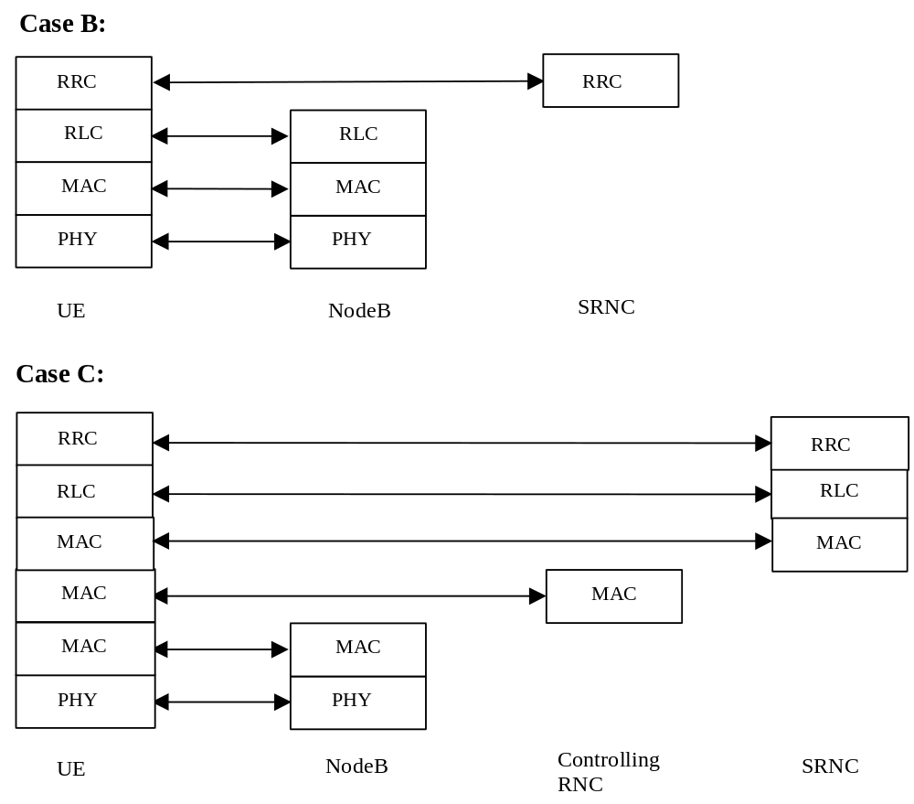
Figure 27: Protocol Termination for RACH/FACH, control plane
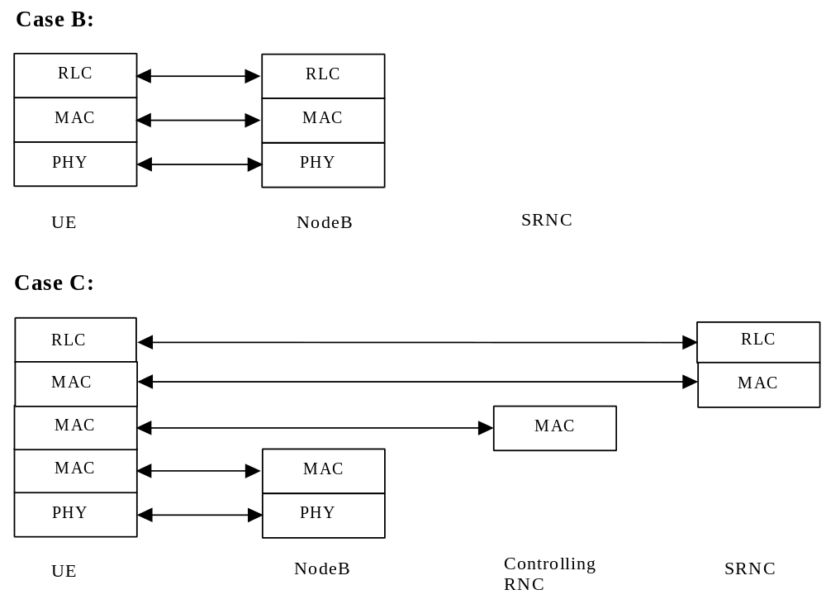
Figure 28: Protocol Termination for RACH/FACH, user plan
A.3 Alternative Protocol termination for transport channel of type PCH
[Note: This section captures the initially assumed PCH termination option before it has been changed.]

Since a Node B possibly can control several cells, the paging distribution signalling can be reduced if the Node B handles the distribution to each cell it controls. This results in less paging signalling on the Iub interface and thus lower processor load for distribution of paging. Protocol termination for the PCH shall therefore reside in the Node B. Note that the RLC sublayer is transparent for this transport channel type.

Figure 29: Protocol termination for PCH
History
Document history
Date | Version | Comment
July 1999 | 1.0.0 | Initial version based on 3GPP TS 25.301 V.3.1.0 Radio Interface Protocol Architecture, this document (V1.0.0) will provided to discussion at the CWTS WG1 Ad Hoc 1 meeting, Aug. 5-7, Chongqing.
Aug 5 1999 | 1.1.0 | After discussion in CWTS WG1 Ad Hoc1 #2 meeting
Sept. 16 1999 | 2.0.0 | After discussion in CWTS WG1 Ad Hoc1 #3 meeting, in Beijing
Oct.14, 1999 | 3.0.0 | Document accepted by CWTS WG1 Ad Hoc1 #4 and CWTS WG1 #5 in Beijing
Editor for TS C001 is: He Yusong
Dr. Shihe Li
CATT
Tel. : +10 6230 2578-201
Fax : +10 62304701
Email : lish@pub.tdscdma.com
This document is written in Microsoft Word version 7.0/97.

This should be clearly separated from the classification of what is transported, which relates to the concept of logical channels. Thus DCH is used to denote that the physical layer offers the same type of service for both control and traffic.

